LAB Logbook

Lab 1

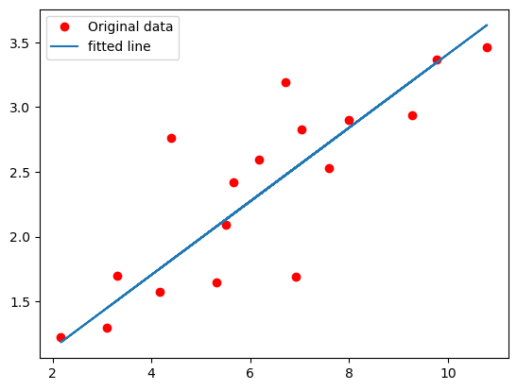

Lab 2

0.93

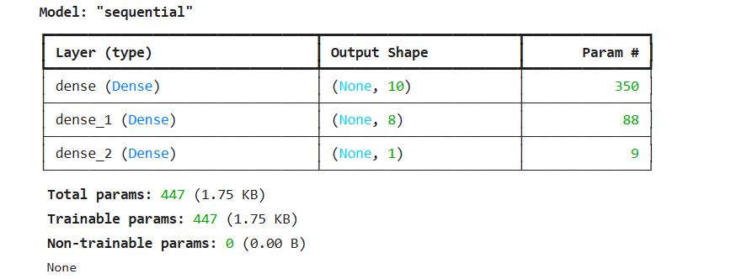

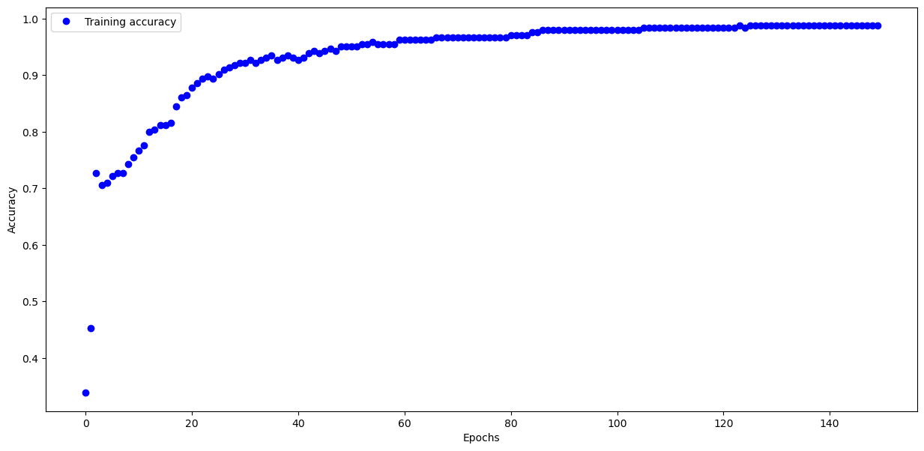

Lab 3

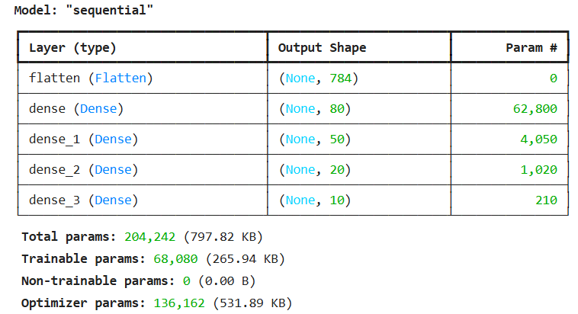

Test accuracy: 0.8870999813079834

Lab 4

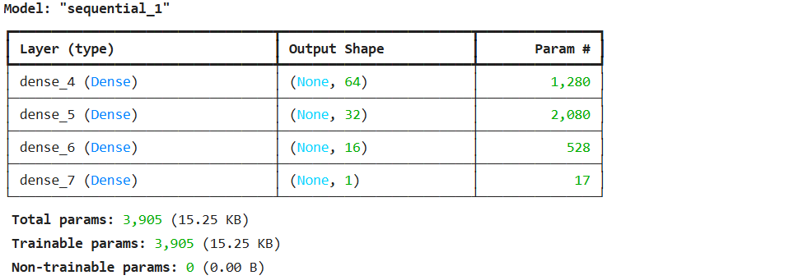

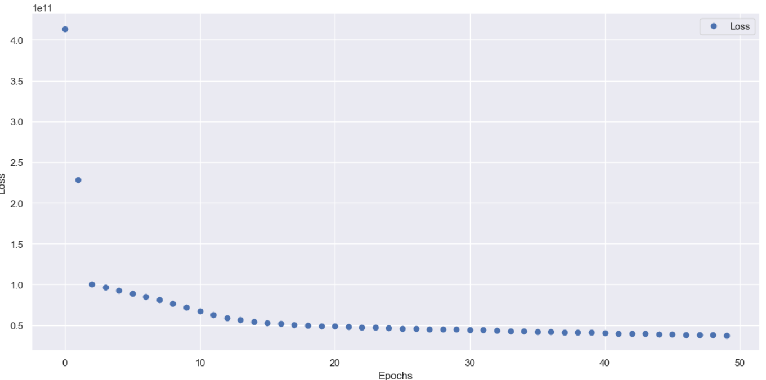

**1/1** ━━━━━━━━━━━━━━━━━━━━ **0s** 118ms/step

absolute prediction error = 41964.0 $

relative prediction error = 18.91122127084272 %

Lab 5

Lab 6

Lab 7